**All About Me**



**Name:**   **Preferred Name:**

**Age: Pathway: Location:**

**My preferred pronouns: he/him she/her they/them**

**Religion:**

**My Normal Routine**

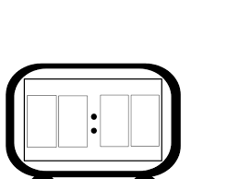

I got to sleep at:I wake up at:

How easy do I find it to fall asleep?

****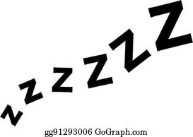

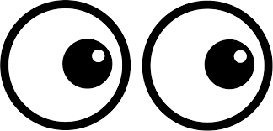

Do I take medication to help me sleep?

……………………………………………………………………………………………………………………………………………………………………………………………………………………………………………………………………………………………………….

What is my normal sleep routine? (Do I wake in the night? Do I have a bedtime routine? Do I use technology at night? etc)

……………………………………………………………………………………………………………………………………………………………………………………………………………………………………………………………………………………………………………………………………………………………………………………………………………………………………………………………………………………………………………

Do I eat breakfast in the morning? Yes / No

What is my normal morning routine? ………………………………………………………………………………………………………………………………………………………………………………………………………………………………………………………………………………………………………………………………………………………………………………………………………………………………………………………………………………………………………………………………………………………………………………………………………………

How much energy do I have during the day? 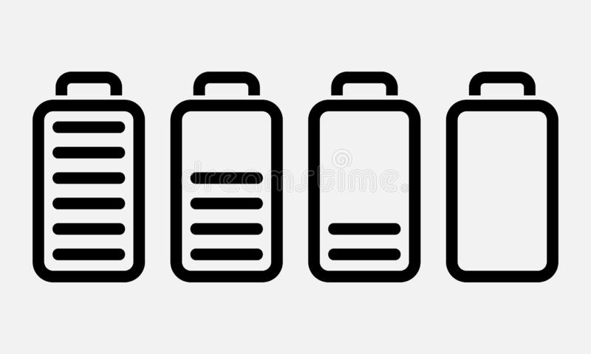

**My Relationships**

Do I like to spend time with my family? Yes / No

Who do I live with? …………………………………………………………………………………………………………………………………………………………………………………………………..



Do I like to spend time alone or with others?



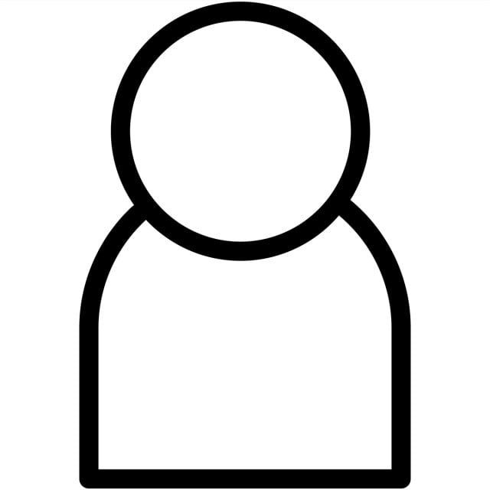

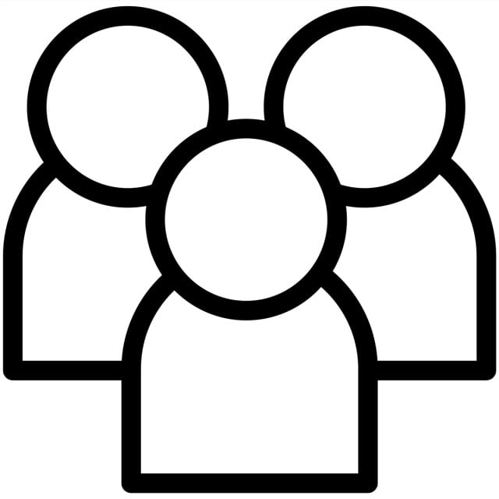

Do I have friends? Yes / No

Do I like to spend time with my friends? Yes / No



Do I have a boyfriend or girlfriend? Yes / No

Do I have imaginary friends? Yes / No Their names are ………………

Do I talk to myself? Yes / No

**My Hobbies and Interests**



How many hours do I spend on my hobbies and interests in a typical week?

**….. ….. ….. …… ….. …… ……**

**M T W Th F S S**

| My favourite songs are: | My favourite things to watch are: |
| --- | --- |
|  |  |

| Places I like to go: | Places I do not like to go: |
| --- | --- |
|  |  |

**Eating and Drinking**

What meals do I eat? 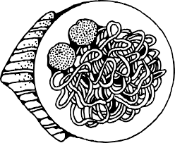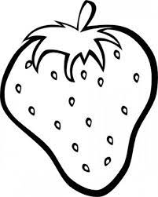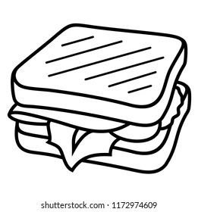

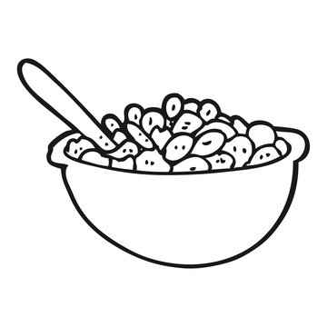

Breakfast Lunch Dinner Snacks

| Foods I like | Foods I don't like | Drinks I like | Drinks I don't like |
| --- | --- | --- | --- |
|  |  |  |  |

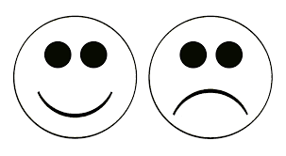

Do I like eating and drinking?

I like (don’t like) my food cooked or presented like this ………………………………………………………………………………………………………………………………………………………………………………………………………………………………………………………………………………………………………

How I eat / drink (cutlery / finger foods / cup / bottle etc) ………………………………………………………………………………………………………………………………………………………………………………………………………………………………………………………………………………………………………

Can I cook for myself / make myself drinks? …………………………………………………………………………………………………………………………………………………………………………………………………….

**Staying Active**

What do I do to stay physically active?

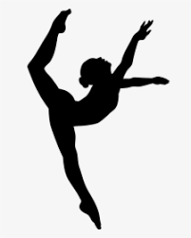

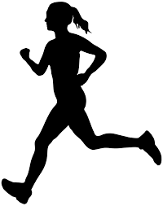 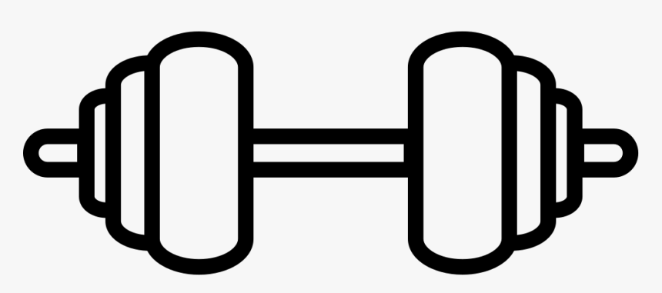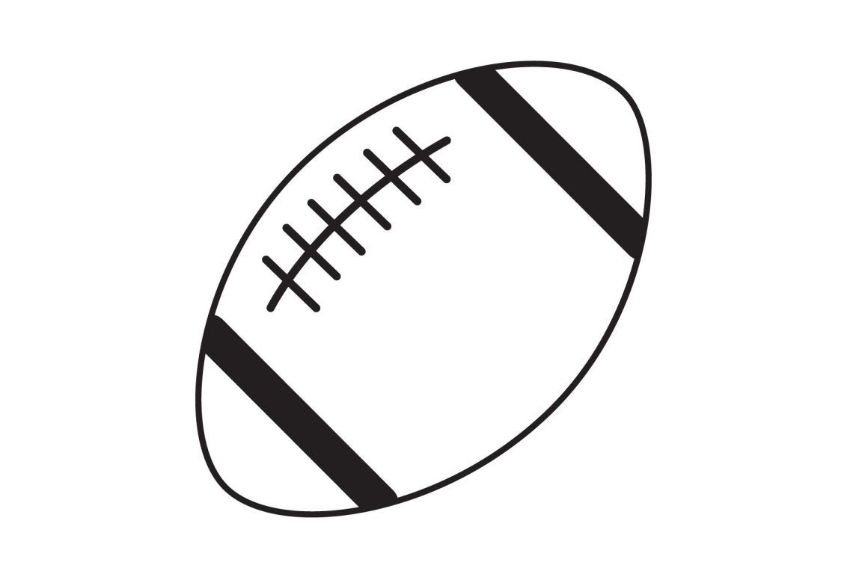

How often do I exercise? …………………………………………………………………………………………………………………………………………………………………………………………………….

Do I enjoy exercising? 

Do I have any physiotherapy needs? …………………………………………………………………………………………………………………………………………………………………………………………………………………………………………………………………………………………………………………………………………………………………………………………………………………………………………………………………………………………………………….



Details of my fine and gross motor skills …………………………………………………………………………………………………………………………………………………………………………………………………………………………………………………………………………………………………………………………………………………………………………………………………………..

**Looking After Myself**

Is my appearance important to me? Yes / No

Am I concerned about what other people think of my appearance? Yes / No

How often do I shower or bathe?

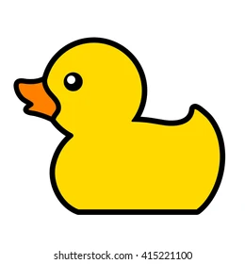

M T W Th F S S

Do other people have to tell me when to shower or bathe? Yes / No

Do I need help to shower or bathe? Yes / No

A description of my personal care needs and how best to support me ……………………………………………………………………………………………………………………………………………………………………………………………………………………………………………………………………………………………………………………………………………………………………………………………………………………………………………………………………………………………………………..

How often do I change my clothes?

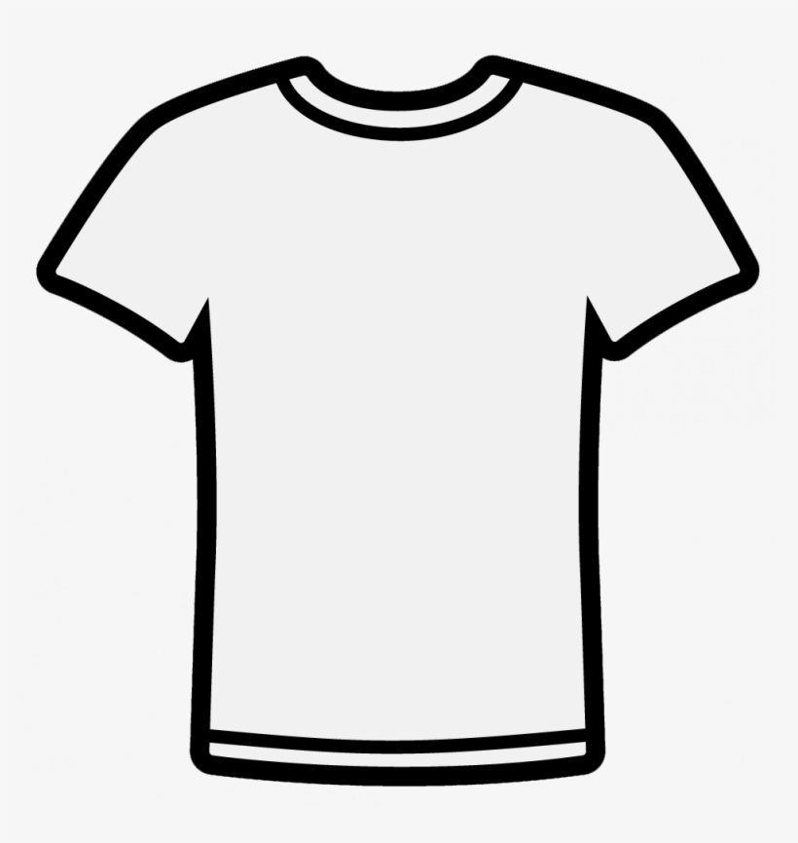

M T W Th F S S

Do other people have to tell me when to change my clothes? Yes / No

Do I need support to help me change my clothes? Yes / No

What support do I need to help me change my clothes? ……………………………………………………………………………………………………………………………………………………………………………………………………………………………………………………………………………………………………….

Am I able to do my own laundry? Yes / No

**My Healthy Mind**

Do I have mental health needs? Yes / No

Do I take medication for my mental health needs? Yes / No

| Things that scare me or make me anxious | How to comfort me and reduce my anxieties |
| --- | --- |
|  |  |



A description of my sensory needs (do I like a quiet space / ear defenders? Do I dislike bright lights? Do labels on clothes irritate me? etc) ………………………………………………………………………………………………………………………………………………………………………………………………………………………………………………………………………………………………………………………………………………………………………………………………………………………………………………………………………………………………………………………………………………………………………………………………………………

**Decision Making and Choices**

Do I find it difficult to make decisions for myself? Yes / No

Who helps me make decisions? …………………………………………………………………………………………………………………………………………………………………………………………………………………………………………………………………………………………………………………………………………………………………………………………………………

How do I make choices? (symbols, pictures, verbally, written, objects etc) …………………………………………………………………………………………………………………………………………………………………………………………………………………………………………………………………………………………………………………………………………………………………………………………………………..

**Medical Needs**

Do I have any medical needs? Yes / No

What are my medical conditions?

…………………………………………………………………………………………………………………………………………………………………………………………………………………………………………………………………………………………………………………………………………………………………………………………………………

Do I need to take medication at home / college?

…………………………………………………………………………………………………………………………………………………………………………………………………………………………………………………………………………………………………………………………………………………………………………………………………………

Can I manage my medical needs myself? …………………………………………………………………………………………………………………………………………………………………………………………………………………………………………………………………………………………………………………………………………………………………………………………………………

Do I have any allergies?