**Trinity Specialist College**

**Career, Information, Advice and Guidance Policy**

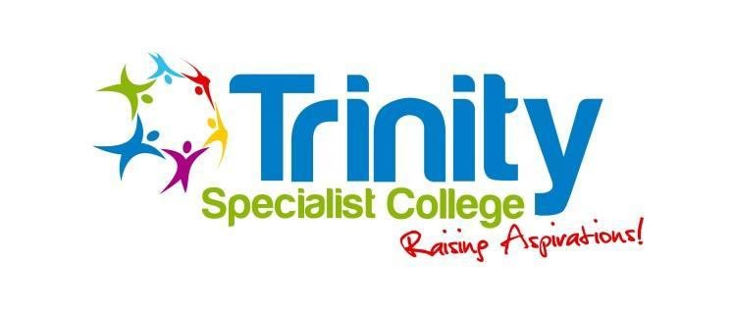

| **Policy reviewed** | October 2024 |
| --- | --- |
| **Date for next review** | October 2025 |
| **Signed by Chair of Trustees:** | Liz Garnham |

**CONTENTS**

| **SECTION** | **PAGE NUMBER** |
| --- | --- |
| 1. **Purpose** | **2** |
| 1. **Definitions** | **2** |
| 1. **Guidance** | **3** |

1. **Purpose**

This policy sets out Trinity Specialist College’s approach to Careers, Information, Advice and Guidance (CIAG). It applies to learners, employers, partners, local authorities and links with the Education, Health and Care Planning (EHCP) process all of which contribute to the learners curriculum plan and destination when they leave college.

Our aim at Trinity Specialist College is to work with learners to recognise their individual strengths and provide opportunities for all to achieve their aspirations linked with Preparing for Adulthood. This includes support to be able to find paid employment if appropriate, live independently or as independently as they can, stay healthy and participate within their community. Learners can draw on their careers experiences to showcase their skills and develop a compelling story for applications and interviews. Learners with special educational needs and disabilities (SEND), including those with high levels of needs, can access fulfilling jobs and careers with the right preparation and support.

1. **Definitions**

Trinity Specialist College uses definitions of the term Careers Advice and Guidance from the

* Careers guidance and access for education and training providers January 2023

<https://assets.publishing.service.gov.uk/government/uploads/system/uploads/attachment_data/file/1127489/Careers_guidance_and_access_for_education_and_training_providers_.pdf>

* Careers strategy: making the most of everyone’s skills and talents December 2017

<https://assets.publishing.service.gov.uk/government/uploads/system/uploads/attachment_data/file/664319/Careers_strategy.pdf>

Other relevant guidance and information

* Supported Internships Guidance February 2022

<https://www.gov.uk/government/publications/supported-internships-for-young-people-with-learning-difficulties/supported-internships>

* Skills for Jobs policy Paper 21st January 2021

:<https://www.gov.uk/government/publications/skills-for-jobs-lifelong-learning-for-opportunity-and-growth>

* Gatsby Good Career Guidance

<https://www.gatsby.org.uk/education/focus-areas/good-career-guidance>

The eight Gatsby benchmarks of Good Career Guidance are:

1. A stable careers programme
2. Learning from career and labour market information
3. Addressing the needs of each pupil
4. Linking curriculum learning to careers
5. Encounters with employers and employees
6. Experiences of workplaces
7. Encounters with further and higher education
8. Personal guidance

3. **Guidance**

Independent, external and impartial CIAG is provided by Birmingham Careers Service Careers,

Information, Advice and Guidance, traded service for schools and colleges. Destination of employment or volunteering twice first year increased two and three

Supported living

Each learner receives an action plan developed by a qualified family transition support

advisor who has SEND experience.The plan links to all work / volunteering aspects of their life and this forms part of their education, health and care plan review. External sources of careers support includes employer visits, mentoring, the website, telephone and helpline access and personal guidance provided externally to the school or college which supports a diverse range of progression pathways.

Destination board.

Trinity Specialist Colleges Careers Information, Advice and Guidance Lead, Family and Transition Support and Job Coach provides ongoing personal guidance including the support with knowledge, skills and confidence learners need for work along with careers education and opportunities, as per section 45 of the Education Act 1997. Trinity Specialist College links with local and national employers to support learners to prepare for the workplace and to make informed choices about the next step in their education or training in line with their careers requirements and the Gatsby Benchmarks. This helps to prepare them for the workplace by providing a clear understanding of the world of work including the routes to jobs and careers that they might find engaging and rewarding, and developing the skills required for work. It supports them to acquire the self-development and career management skills they need to achieve positive employment destinations.

The careers programme at Trinity Specialist College is linked with the needs and aspirations of the individual.

Learners can talk to Naomi Hague about work and voluntary opportunities

Naomi Hague -Trinity Specialist College Information, Careers, Advice and Guidance Lead.

Email: n.hague[tsc@gmail.com](mailto:a.westwoodtsc@gmail.com)

Telephone number: 07908 730612

Parents or carers can access information about careers, work and volunteering for learners at Trinity Specialist College in addition to providing progress reports, EHCP reviews and accessing websites.

Employers that wish to know more about supporting learners with a work placement can contact Stephanie Peers

Stephanie Peers - Trinity Specialist College Job Coach

Telephone number: 07904 032750

Staff members can explore opportunities for learners by sharing any ideas about enterprise projects and booking in work experience or voluntary placements with Naomi Hague.

Trinity Specialist College aspires to educate by sharing information, offer training on individual needs and skills along with providing information that would benefit a business such as job carving.