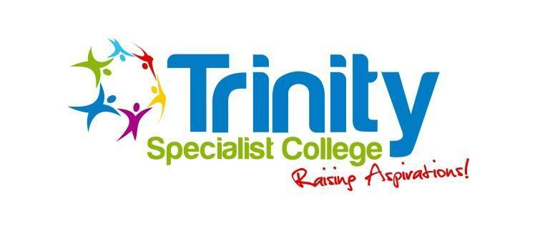

**Equality and**

**Diversity Policy**

| **Policy reviewed** | 5th September 2024 |
| --- | --- |
| **Date for next review** | 5th September 2025 |

**Introduction**

Everyone is different and has something unique to offer Trinity Specialist College and the young people who use its services.

**Diversity** is about understanding, recognising, respecting and valuing differences.

**Equality** is about managing differences so that everyone has equality of opportunity through a fair and consistent approach to the application of rules, policies and procedures. This does of course mean that people will sometimes be treated differently.

Trinity is committed to providing services that embrace diversity and provide equality of opportunity. We recognise, value and promote the positive contributions that are made by the learners who use our services in contributing to the direction of the service they receive and the college itself.

We recognise the value of a diverse workforce and volunteers, and the broad range of benefits that this can bring to the service delivery to learners and the operation of the college as a whole.

We are determined to ensure that these values underpin our everyday practice; our support to learners; our respect for colleagues; and our presence and work within communities.

We will not tolerate discrimination of any sort directed at learners, staff or volunteers. Neither will we tolerate direct or indirect behaviours that are intended to bully, harass, isolate or victimise others for reasons associated with individual differences.

**Principles**

* We will listen to the varying views of colleagues and seek to understand their perspectives.
* We will respond promptly where concerns relating to the values of this policy are raised.
* We will be respectful, honest and open in all our interactions with colleagues and the learners who attend the college.
* We will be honest and open about the diversity of our workforce.
* We will involve staff and learners in resolving issues; always encouraging informal resolution where appropriate in order to maintain engagement and positive working relationships.
* We will continue to promote a positive culture throughout, where opinions are welcomed; differences embraced; and where equality, diversity and respect are core values placed at the centre of all our activities.
* We will ensure the highest possible standards are achieved in service delivery and employment practices.
* A commitment to this policy and its principles is expected from everyone who works for us; alongside us; or is engaged with us in any way.

**Promoting Equality and Diversity**

We will ensure that no person or groups of people suffer detriment in recruitment; promotion; development; exit from the company; with access to training, facilities or other benefits, or will endure discriminatory behaviour in their everyday work or when they are in receipt of services from us.

We will work towards a culture where discriminatory behaviour is routinely challenged in a respectful and constructive manner so that the person displaying such behaviour has an opportunity to correct this. If they are unwilling to correct their behaviour or if the behaviour is considered to be of a serious or detrimental nature, then disciplinary action should result. Their continued employment with us will be considered in line with our disciplinary policy and procedure.

All complaints of discrimination; bullying; harassment; victimisation; intolerance; or lack of respect for individuals will be fully investigated and if proven beyond reasonable doubt, will result in disciplinary action.

**General Standards of Behaviour**

Everyone is expected to conduct themselves in a professional and considerate manner at all times. We will not tolerate behaviour such as:

* Bullying; harassment or victimisation
* Psychological or emotional abuse
* Physical violence
* Shouting or swearing
* Isolating, ignoring or refusing to work or communicate with certain individuals – whether intentional or otherwise
* Telling offensive or potentially offensive jokes or name calling
* The display of offensive material such as pornography or sexist/racist cartoons
* Lewd gestures or remarks
* Distribution of offensive or potentially offensive material by any means including email or text messaging

We are all responsible for our own behaviours and therefore, for considering the impact that our behaviours may have on others. It is the impact of the behaviour (i.e. how your behaviour affects someone else) rather than the intent that is of paramount importance. It is not acceptable to justify our actions by either denying; inferring others are overly sensitive or by saying we did not intend any offence to be caused.

**Responsibilities and who this policy effects**

We believe it is the responsibility of everyone involved with Trinity to uphold strong working practices.

Everyone involved with us has a duty to:

* Promote equality and diversity in the delivery of services
* Undertake training or development about equality & diversity issues
* Ensure that everyone associated with us is treated in a non-discriminatory manner
* Promote a welcoming environment in which individuals from all backgrounds feel welcome, valued and respected
* Act in a respectful and tolerant manner at all times
* Challenge any behaviour that could be considered as unfair or discriminatory, or raise such issues with your line manager if you feel unable to challenge it
* Be clear about what is expected of us in terms of our behaviour and conduct towards others
* Be a positive role model and set positive examples in everything we do
* Listen to and respect others, and do not dismiss their concerns as trivial

**What to do if you are concerned or feel you have been discriminated against**

If you believe that you have been subject to bullying, harassment, discrimination or victimisation of any kind then you should discuss this with your line manager to try to resolve the matter. If this does not resolve the issues (or you don’t feel you can approach them) then you should discuss it with the HR Manager or Designated Safeguarding Lead.

If the issues are unable to be resolved informally then you should raise your concerns as a grievance, referring to the grievance procedure.

Where we have formed a reasonable belief that this policy has been breached and/or acts of discrimination, harassment or victimisation have occurred then such issues will be managed by the Disciplinary Policy.