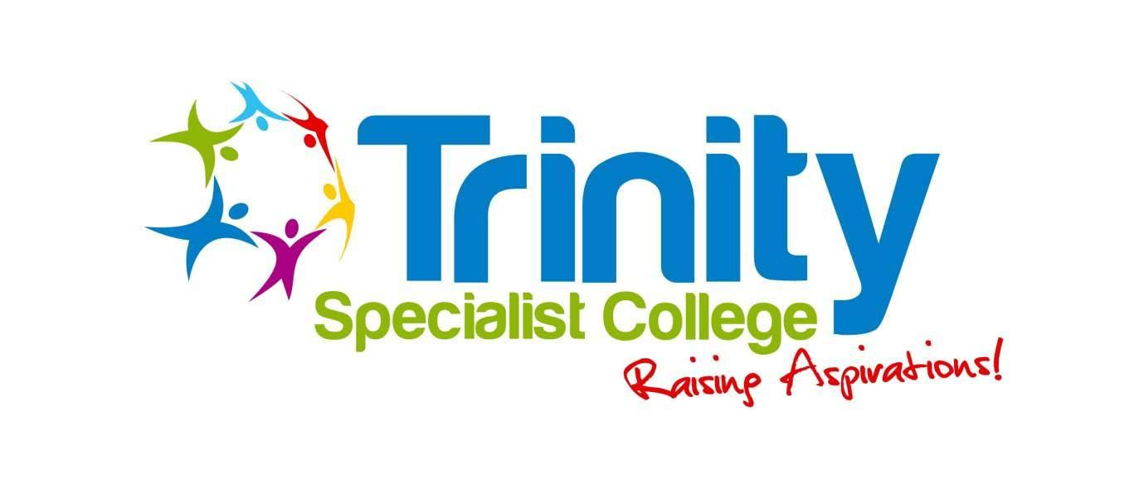

**Trinity Specialist College**

**Parents/Carers Code of Conduct**

| **Policy Reviewed** | April 2024 |
| --- | --- |

At Trinity Specialist College we are very fortunate to have a supportive and friendly parent/carer body. Our parents/carers recognise that educating learners is a process that involves partnership between parents/carers, teachers, support staff and the wider college community. As a partnership, our parents/carers will understand the importance of a good working relationship to equip learners with the necessary skills for adulthood. For these reasons we continue to welcome and encourage parents/carers to participate fully in the life of our college. The purpose of this policy is to provide a reminder to all parents/carers and visitors to our college about the expected conduct.

With these values in mind, we expect parents/carers to respect the caring ethos of our college by:

* Understanding that both teachers and parents/carers need to work together for the benefit of their young person.
* Demonstrating that all members of the college community should be treated with respect and therefore set a good example in their own speech and behaviour when communicating with any member of the college.
* Seeking to clarify a young persons version of events with the college’s view in order to bring about a peaceful solution to any issue.
* Correcting their own young person’s behaviour especially in public where it could otherwise lead to conflict, aggressive behaviour or unsafe behaviour.
* Approaching the college courteously to help resolve any issues of concern.
* Avoiding using staff as threats to influence learner’s behaviour.
* Not adding members of college staff on social media sites.
* Contacting college staff between their working hours only.

In order to support a peaceful and safe college environment, the college cannot tolerate parents/carers and visitors exhibiting the following:

* Disruptive or aggressive behaviour.
* Being rude or using offensive or threatening language to members of college staff, visitors, fellow parents/carers or learners; in person, over the telephone or in written communication, this includes social media.
* Approaching another learner or parent/carer of a young person in order to discuss the actions of that person towards another or to chastise them for those actions.
* Smoking and consumption of alcohol or other drugs whilst on college property.
* Dogs being brought onto college premises.

Inappropriate use of social media websites can sometimes be used to fuel campaigns and complaints against college, the Principal, college staff, and in some cases other parents/carers/learners. The Board of Trustees considers the use of social media websites in this way as unacceptable, and not in the best interests of the learners or the whole college community. In serious cases the college will also consider taking advice as to its other options in dealing with any such misuse of social networking and other sites. Any concerns you may have about the college, must be made through the appropriate channels by speaking to the college teacher, the Principal or the Board of Trustees, so they can be dealt with fairly, appropriately and effectively for all concerned. We would expect that parents/carers would make all persons responsible for collecting the young person’s aware of this policy.

Should any of the above behaviour occur on college premises the college may feel it is necessary to contact the appropriate authorities and if necessary, ban the offending person from entering the college grounds. We trust that parents/carers will assist our college with the implementation of this policy and we thank you for your continuing support of the college.